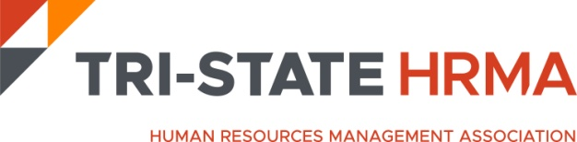

**38th Annual Conference**

**Thursday, May 1, 2025**

**Call for Auction Donations**

Dear Fellow Members and Friends,

Continuing our tradition of giving back to the community, we will be hosting a Chance Auction at the 2025 Tri-State Human Resource Management Association (HRMA) Annual Conference. The conference is scheduled as an in-person event at the Westin Mt Laurel on Thursday, May 1, 2025.

Over 250+ Human Resources Professionals attend the conference and this year we are hoping for an even greater turn out of attendees and exhibitors. The Auction provides participants with the opportunity to purchase chances to win items donated by organizations and friends like you, with proceeds benefiting a designated local charity. This year, auction proceeds will benefit **The Arc of Camden, https://arccamden.org/**

**WHY DONATE TO THE ARC OF CAMDEN COUNTY?**

Help us to help others. It’s that simple. The Arc of Camden County serves hundreds of people with disabilities each year. We bring them functionality, friendship, and dignity through life skills learning and compassion. But we can’t function without your generosity.

Contributions through membership and general donations for The Arc of Camden County make possible purchases of special communications and mobility equipment, transportation to job sites, workshops for family members, and a host of supports and services for hundreds of residents of Camden County.

*How can you help?*

We are seeking donations and invite your participation. Past donations have varied in value and creativity and have included merchandise, gift cards/certificates, tickets for movies, museums, sporting or special events, etc. To make a donation please email the conference committee at [jkotsakis@foodbanksj.org](mailto:jkotsakis@foodbanksj.org) with the following information:

## **Company Name Gift Name Items to be donated $ Value of Donation**

On behalf of Tri-State HRMA, we extend our sincere appreciation and thank you for your consideration and support of our organization and designated charities.

Sincerely,

Tri-State HRMA Conference Committee [www.tristatehr.org](http://www.tristatehr.org)