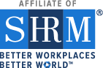

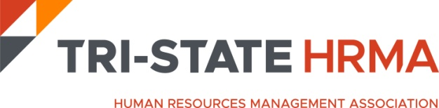

37th Annual Conference
Thursday, May 2, 2024
Call for Auction Donations

Dear Fellow Members and Friends,

Continuing our tradition of giving back to the community, we will be hosting a Chance Auction at the 2024 Tri-State Human Resource Management Association (HRMA) Annual Conference. The conference is scheduled as an in-person event at the Westin Mt Laurel on Thursday, May 2, 2024.

Over 250+ Human Resources Professionals attend the conference and this year we are hoping for an even greater turn out of attendees and exhibitors. The Auction provides participants the opportunity to purchase chances to win items donated by organizations and friends like you, with proceeds benefiting a designated local charity. This year, auction proceeds will benefit Book Smiles https://www.booksmiles.org/.

BookSmiles, a 501(c)(3) nonprofit (EIN 82-3233733), promotes literacy and the joy of reading by giving books to children who need them most throughout Philadelphia and New Jersey. We provide students and younger siblings with high-quality new or gently used books, laying the groundwork for academic success. Educators – especially those representing Title I schools – receive books for classroom libraries, for students to keep at home and for pop-up book fairs. We “irrigate book deserts”!.
How can you help?

We are seeking donations and invite your participation. Past donations have varied in value and creativity and have included merchandise, gift cards/certificates, tickets for movies, museums, sporting or special events, etc. To make a donation please email the conference committee at tschanceauction@gmail.com with the following information:

Company Name Gift Name Items to be donated $ Value of Donation

On behalf of Tri-State HRMA, we extend our sincere appreciation and thank you for your consideration and support of our organization and designated charities.

Sincerely,
Tri-State HRMA Conference Committee www.tristatehr.org

